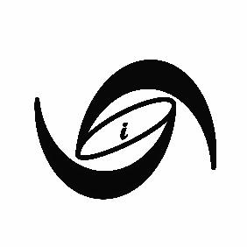
Mixed LLC Bulk/Custom Request Form
Email form to: mixed2020llc@gmail.com
Date: | Click or tap here to enter text.
Name: | Click or tap here to enter text.
Company (if applies) | Click or tap here to enter text.
Phone: | Click or tap here to enter text.
Address: | Click or tap here to enter text.

Please fill out the form below to completion for a quote for your items. If you have a decal/design you would like to use, please also send this as an attachment with the form.
☐ Embroidery – color limit 10
☐ Direct to Garment Printing – no color limit
☐ Sublimation (mugs, tumblers, keychains)
☐ Heat Transfer Vinyl – color limit 2

Item Name  (ex. T-shirt, mug, mask) | Quantity | Color(s) of item(s) | Description of design  (ex. One design in front center of T-shirt with decal on sleeve. One photo on side of mug with words on other side)
Choose an item.
Choose an item.
Other (if you need more explanation space or item not in drop down menu: Click or tap here to enter text.

Prices for Services

Logo design & customization
Design/customization of logo - $20 (One-time fee)

Embroidery (limit of 10 colors)
Vectorization/customization of file if not embroidery file already - $20
General small name or logo price - $8
$1 per 1,000 stitches

DTG Printing (Direct to Garment print, unlimited colors)
T-shirt - $12 one side - $5 extra for 2 sides
Long Sleeve - $15 one side - $5 extra for 2 sides
Sweatshirt - $22 one side - $5 for 2 sides

Sublimation Ink - Accessories – unlimited colors
Personal tote bag - $15
Tumbler cup - $25
Personalized mug white - $10
Personalized mug black - $13
Stickers up to 4”x4” on white normal sticker paper - $0.25 each
Stickers up to 4”x4” on transparent sticker adhesive or vinyl stickers - $0.50 each

Heat Transfer Vinyl Press only (Per Shirt)
Press only – (one color) - $6.50
Press only- (2 colors)- $8
Personalization on back of shirt (1 color) - $5
Sleeve Decal - $3
T-shirt –$10/ shirt one side - Heavy blend
Long Sleeve - $15 one side
Sweatshirts - Heavy Blend one side –$20
Mask - $5
Hat - $10
Sweats - $20

